# .Net Core Publish

## Manual

Right Click 🡪 Publish

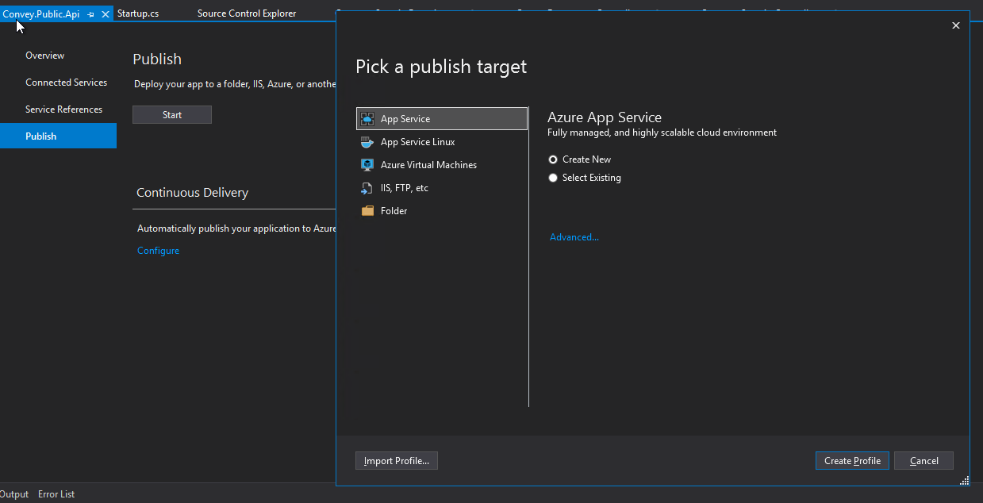

### Advanced setting

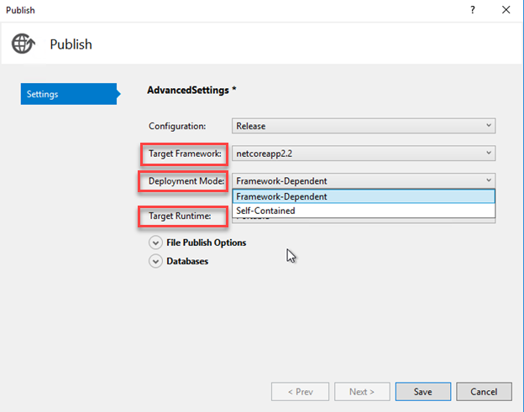

Advanced Settings

* Target Framwork
* [Deployment mode](https://docs.microsoft.com/en-us/dotnet/core/deploying/)
  + Framework-Dependent /runtime-dependent (separately install the .NET Core runtime)
  + Self-Contained (Without .NET Core runtime installed)
* Target Runtime

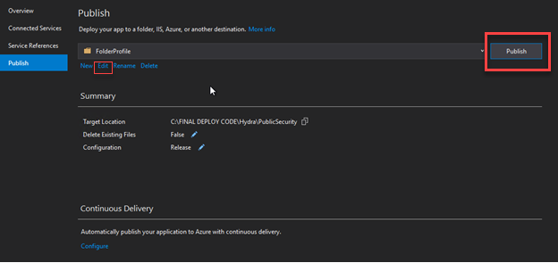

### AppService Publish

## Automated

# Host and deploy

<https://stackoverflow.com/questions/40805402/http-error-500-19-when-publish-net-core-project-into-iis-with-0x80070005>

## [Install the .NET Core Hosting Bundle](https://docs.microsoft.com/en-us/aspnet/core/host-and-deploy/iis/?view=aspnetcore-3.1#install-the-net-core-hosting-bundle)

[ASP.NET Core 3.1 Runtime (v3.1.5) - Windows Hosting Bundle Installer](https://dotnet.microsoft.com/permalink/dotnetcore-current-windows-runtime-bundle-installer)

## [IIS configurations](https://docs.microsoft.com/en-us/aspnet/core/host-and-deploy/iis/?view=aspnetcore-3.1#iis-configuration)

.NET CLR version=**No Managed Code**

Machine generated alternative text:
Edit Application Pool 
Name: 
adminUi 
CLR version: 
No Managed Code 
.NET CLR v4.o.3031g 
.NET CLR Version „2.0.50727 
NC Managed Code 
Stat applicati 
mediately 
Cancel 

**For** 32-bit (x86)**Applications** 

Application Pools 🡪 Advanced Settings. Set Enable 32-Bit Applications to True

**For** 64-bit (x64)**Applications** 

Application Pools 🡪 Advanced Settings. Set Enable 32-Bit Applications to False